1 Configure the following network with DNS, Gmail, and Yahoo servers using class B private addressing.

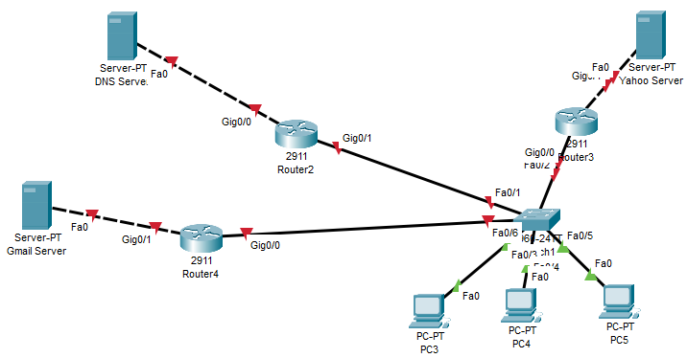

2. Perform static routing on the following network using class B private addressing.

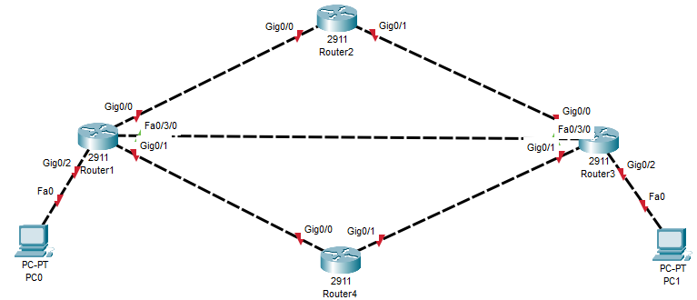

3. Use class A IP addressing to implement static routing on the following network.

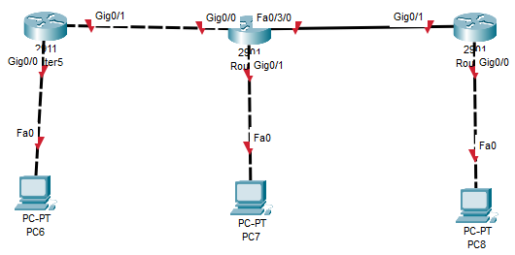

4. Configure the following network with 2 DHCP servers using class C private addressing.

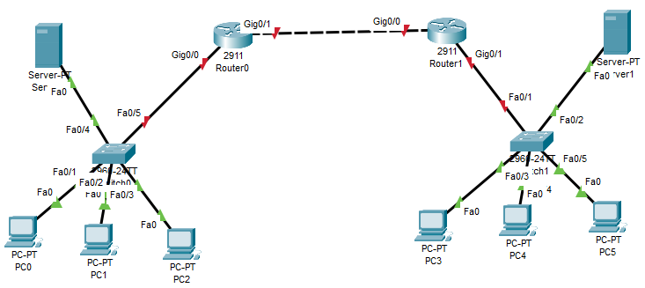

5. Configure the below network using IP addressing of class A along with one HTTP server.

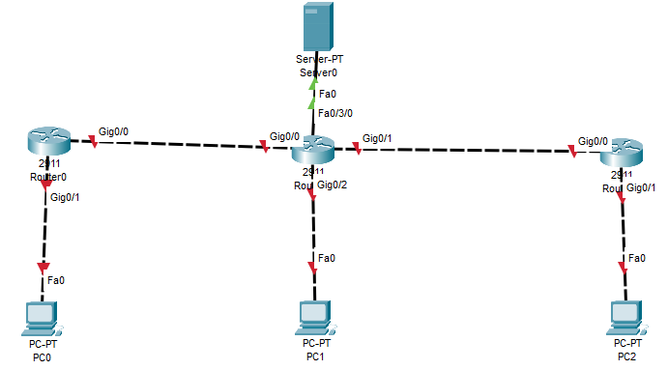

6. On the following network, configure the dynamic routing along with one DHCP server configuration using class C addressing.

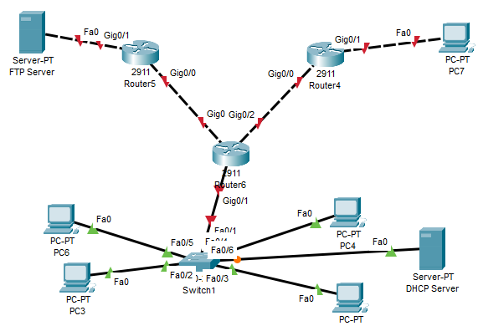

7. Use class C addressing to configure the FLSM concept on the following network.

